**AWS EC2 COMPUTE LIFE CYCLE MANAGER**

You can use Amazon Data Lifecycle Manager to automate the creation, retention, and deletion of EBS snapshots and EBS-backed AMIs. When you automate snapshot and AMI management, it helps you to:

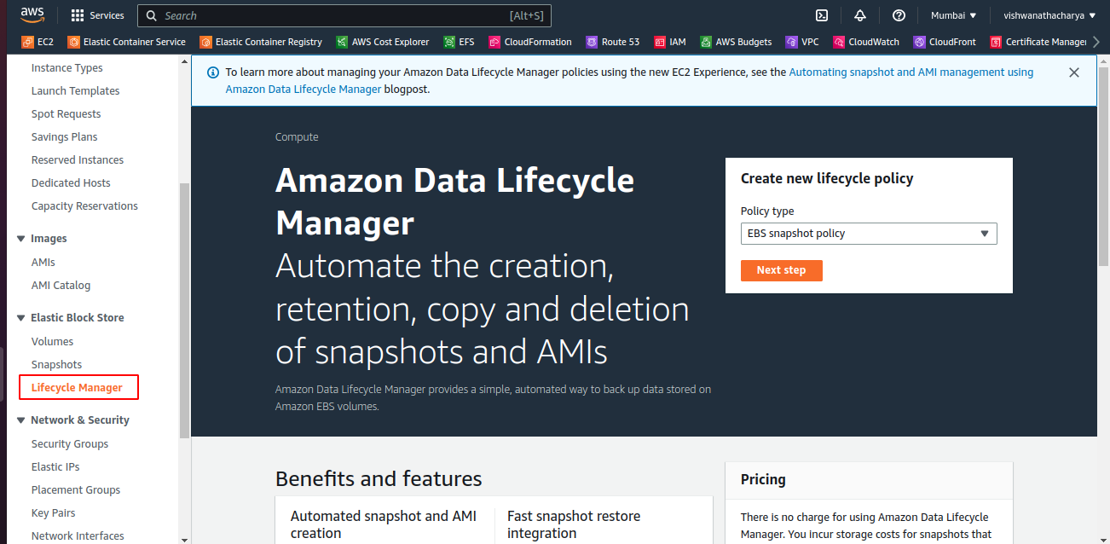

Protect valuable data by enforcing a regular backup schedule.

Create standardized AMIs that can be refreshed at regular intervals.

Retain backups as required by auditors or internal compliance.

Reduce storage costs by deleting outdated backups.

Create disaster recovery backup policies that back up data to isolated accounts.

### **Snapshots**

Snapshots are the primary means to back up data from your EBS volumes.

### **EBS-backed AMIs**

EBS-backed AMIs include a snapshot for each EBS volume that's attached to the source instance.

### **Target resource tags**

Amazon Data Lifecycle Manager uses resource tags to identify the resources to back up.

### **Lifecycle policies**

Snapshot lifecycle policy

EBS-backed AMI lifecycle policy

Cross-account copy event policy

**Resource type**

VOLUME

INSTANCE

**Policy schedules:**Define when snapshots or AMIs are to be created and how long to retain them for.

